| **PROJECT INFORMATION** | | | |
| --- | --- | --- | --- |
| ***Report Description:*** | **Literature review for Feature Extraction of EEG signals** | | |
| ***Professor:*** | **Prof.** [**Gady Agam**](mailto:agam@iit.edu) | ***Tools used/work done:*** | 1. **Literature Review on feature extraction of EEG** 2. **CITI program - In progress** |
| ***Report prepared by:*** | [**Noviya Balasubramanian**](mailto:nbalasubramanian@hawk.iit.edu) |
| ***HAWK ID:*** | **A20541236** |
| ***Report no:*** | **2** | ***Report Date:*** | **8/29/2024** |

**Work done:**

* Had a call with Xiaoting and Xuanchang to discuss the project outline and clarify a few questions.
* Got a chance to read their paper and research works to understand the data collection.
* Obtained details about CITI programs from Xiaoting. Will complete all the courses to get access to data.

Completed COI:

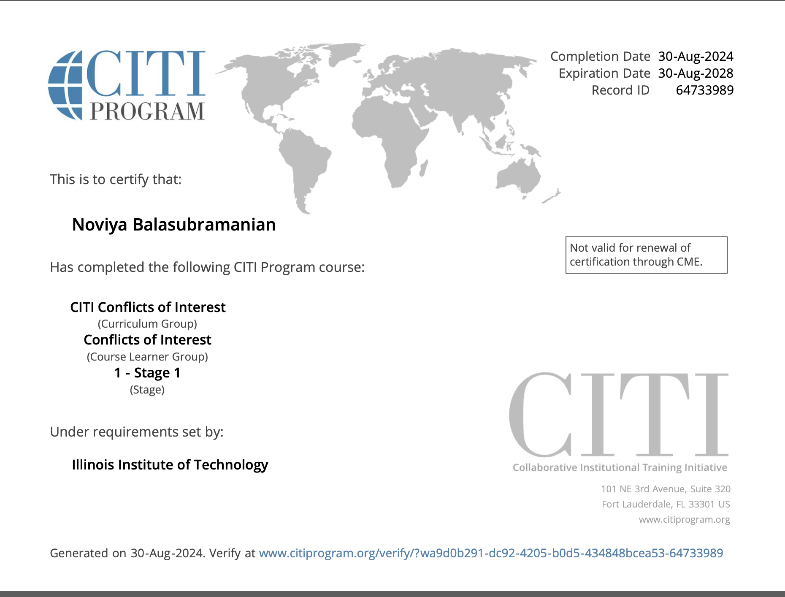

* Conducted a literature review focused on feature extraction.

**Feature extraction of EEG data:**

Feature extraction is the process of obtaining only the essential information from the raw data. Since the raw data might contain lots of information that does not support the objective, feature extraction is performed which removes all the redundant information and only the required feature will be extracted.

**Literature review:**

**[1] “Electroencephalography Signal Processing: A Comprehensive Review and Analysis of Methods and Techniques“**

Summarized different denoising techniques:

1. **Blind Source Separation (BSS) - Independent Component Analysis (ICA)**

decomposes the EEG signal into its components, identifies artifacts, and removes them.

Advanced ICA methods, such as ERASE

1. **Principal Component Analysis (PCA)**: Reduces dimensionality of EEG data by focusing on components with the highest variance - reduces noise.

Useful for general noise reduction but less effective for specific artifact types compared to ICA.

1. **Canonical Correlation Analysis (CCA):** Distinguishes between brain activity and muscle artifacts by maximizing correlation between EEG and artifact signals. Particularly effective for muscle artifacts, but might be less effective for other types of artifacts.
2. **Discrete Wavelet Transform (DWT):** Decomposes EEG signals into different frequency components to identify and remove artifacts.

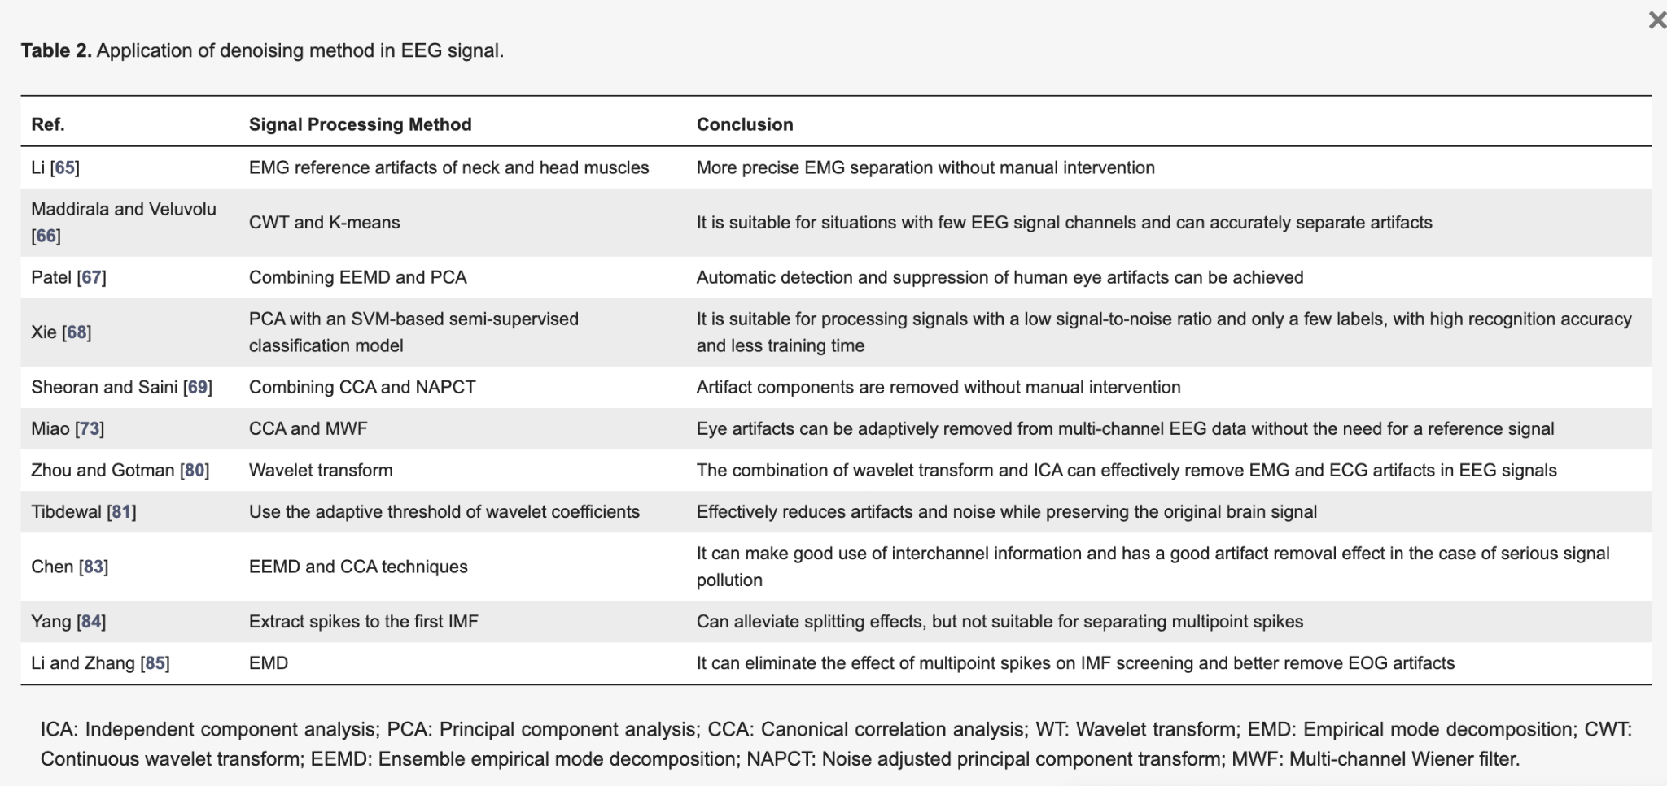

Feature Engineering

1. **Time–Frequency Analysis:** Combines time and frequency domains to extract features, Techniques include variance analysis and peak detection, Useful for mapping and detecting features like epilepsy.
2. **High-Order Spectral Analysis:**Improves upon time domain methods by analyzing high-order information. Effective in neuro-marketing and emotion detection, using techniques like PCA and SVM.

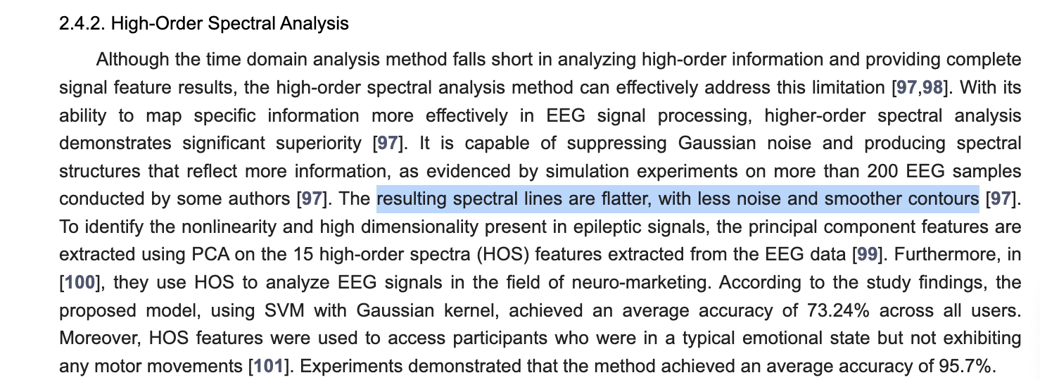

1. **Nonlinear Dynamic Analysis:**Uses techniques like the Lyapunov exponent and complexity measures. Effective in distinguishing emotional states with methods like adaptive Lempel–Ziv complexity.

**[2] Exploring Convolutional Neural Network Architectures for EEG Feature Extraction**

1. Channel selection:

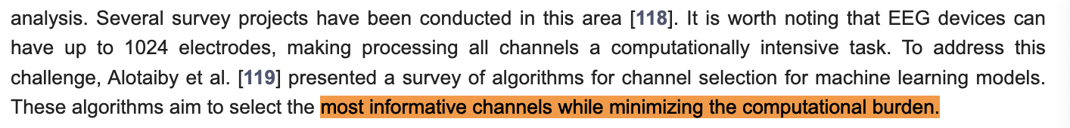

Our approach: Heatmap approach (so this method is unnecessary)

1. Autoencoder: For EEG signal classification, **autoencoders** and **LSTMs** (especially with **BiRNNs** for bidirectional processing) generally provide the best performance. Autoencoders enhance CNNs by effectively reducing dimensionality, while LSTMs excel at handling temporal dependencies in EEG data.

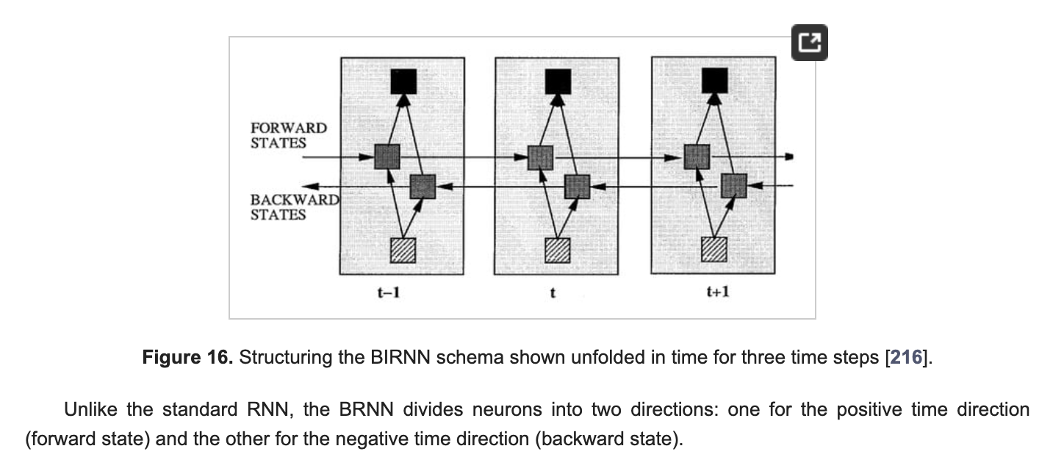

In the CNN approach, the raw data is passed into CNN and done in different ways.

[3] & [4] Yet to completely read Xuanchang’s papers and Xiaoting’s approach with physiological data